Iris Flower Classification using Naïve Bayes Classifier
Aim
To implement the Naïve Bayes Classifier in Python for classifying Iris flowers into different species using the Iris dataset.

Apparatus Required
- Google Colab / Jupyter Notebook
- Python 3
- Libraries:
  - NumPy
  - Pandas
  - Scikit-learn (sklearn)

Theory
The Naïve Bayes algorithm is a supervised machine learning classification algorithm based on Bayes' Theorem. It assumes that all input features are conditionally independent given the class label. In this experiment, the Gaussian Naïve Bayes classifier is used because the Iris dataset contains continuous-valued features.
The Iris dataset contains 150 flower samples of three species:
- Iris Setosa
- Iris Versicolor
- Iris Virginica
Each sample includes four features:
- Sepal Length
- Sepal Width
- Petal Length
- Petal Width

Algorithm
- Import the required libraries.
- Load the Iris dataset.
- Split the dataset into training and testing sets.
- Create and train the Gaussian Naïve Bayes classifier.
- Predict the species of the test samples.
- Calculate the Accuracy.
- Display the Confusion Matrix and Classification Report.

Code (Google Colab)
from sklearn.datasets import load_iris
from sklearn.model_selection import train_test_split
from sklearn.naive_bayes import GaussianNB
from sklearn.metrics import accuracy_score, confusion_matrix, classification_report

# Load Iris dataset
iris = load_iris()
X = iris.data
y = iris.target

# Split dataset
X_train, X_test, y_train, y_test = train_test_split(
X, y, test_size=0.3, random_state=42
)

# Create and train Naïve Bayes model
nb = GaussianNB()
nb.fit(X_train, y_train)

# Predict
y_pred = nb.predict(X_test)

# Display results
print("Predicted Classes:")
print(y_pred)

print("\nAccuracy:")
print(accuracy_score(y_test, y_pred))

print("\nConfusion Matrix:")
print(confusion_matrix(y_test, y_pred))

print("\nClassification Report:")
print(classification_report(y_test, y_pred, target_names=iris.target_names))

Sample Output
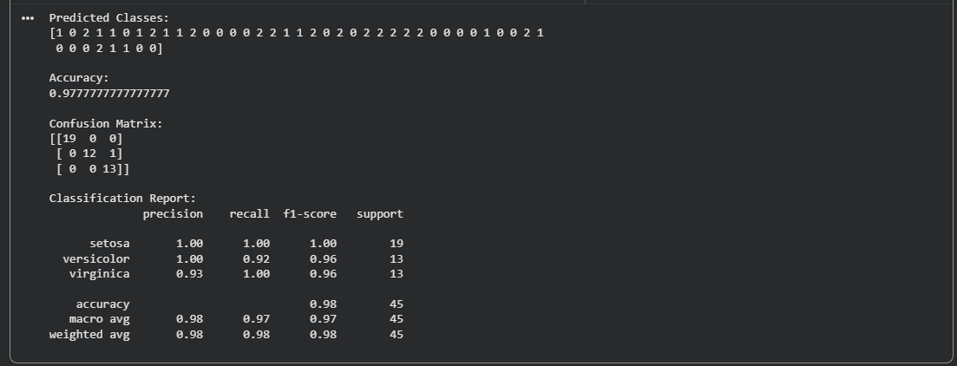
Result
The Iris Flower Classification was successfully implemented using the Gaussian Naïve Bayes classifier in Python. The model accurately classified the Iris flowers into Setosa, Versicolor, and Virginica, and its performance was evaluated using Accuracy, Confusion Matrix, and the Classification Report.

